Thoughts on Stewardship
The decision to share with the Lord is not made with a pencil but with the heart.
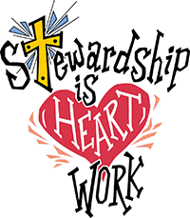From Pastor Bob Patrick: “For me personally, the key to making giving decisions has always been to understand that I am a recipient of God’s gifts. I have done nothing to deserve or earn the gifts which God has showered upon me. But through my giving I have the opportunity to respond to God’s generosity to me, knowing that my gift will both help other people and free me from the unhealthy dependence on material ‘things’. “ He goes on to say, “For Joyce and me the commitment to tithe means that we literally set aside for God’s use the ‘first fruits’ of our harvest. The first check of the month that we write is always our tithe. This way, instead of giving God the leftovers, we commit to the Lord’s work our tithe and then live on the remainder. It works! It is not a heavy burden! And it feels good to respond to God’s love in this way! And as we then see how God can use our gifts for others’ benefits, our faith grows stronger and stronger.”
Daniel Webster once said, “The most important thought I ever had was that of my individual responsibility to God.”
“A sense of security comes scarcely at all from reliance on money or property, but from seeking the kingdom and its righteousness (Matthew 6:33) and resting in God who is our ultimate security.” – Alvin N. Rogness

