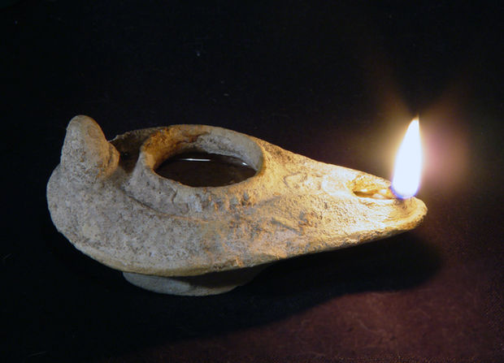
“Your word
is a lamp to my feet
and a light
to my path.”
~Psalm 119:105

December 31, 2019

Dear Brothers and Sisters in Christ,

As we put the last year into hindsight, we look forward again to what is to come. One might hope that in the year of our Lord 2020, we could expect deeper insight, clearer vision, and a more defined sense of purpose. That is certainly my hope for who we are as Church together and who you are as the body of Christ in your community.
There are those among you who might remember a time when the future of the congregation stretched in an unbroken and unswerving line. Councils and congregational leaders could, with some certainty, make plans for 5, 10, even 20 years in the future.
I do not believe that our current situation allows for such a long view. I think of the oil lamps of our ancient ancestors. My father enjoyed many excursions to the holy land on archeological digs. He brought home pottery shards and mosaic pieces, and a reproduction of an ancient oil lamp. This small lamp was a staple for any ancient household just as a flashlight is today. The lamp fits easily in the palm of your hand, with a small bowl to hold the oil and a smaller opening at one end to hold the wick for burning. And this hand-held lamp would give off just enough light for the person holding it to take one more step. The light from this small clay bowl would not illuminate the whole path. But it would ensure that your next step would be safe as you would be able to see any immediate hazards, holes, uneven ground, or danger.
The Word of God, that is, the word made flesh in Jesus, is the light that will show us our next steps, one step at a time. We will not, cannot, see the entirety of our future. But digging into the life of Christ in study, prayer, conversation, and worship will most certainly shine a light.
I invite you to seek clearer vision in 2020, as a person of faith and as the Body of Christ journeying together. Look through the lens of the life & ministry and the death & resurrection of our Savior and Lord to see more clearly what direction, what effort, what decisions, what next step will be a faithful reflection of the light of Christ in your community and the world.
As we journey together into 2020, I pray that God would give us enough light for the next step and courage to follow where Jesus leads.
Be Thou my Vision, O Lord of my heart
Naught be all else to me, save that Thou art
Thou my best Thought, by day or by night
Waking or sleeping, Thy presence my light.
~ELW #793

Yours in Christ,
Bishop Katherine Finegan

