“You do well
if you really fulfill the royal law according to the scripture,
‘You shall love your neighbor
as yourself.’”
~James 2:8

Dear Northern Great Lakes Synod,
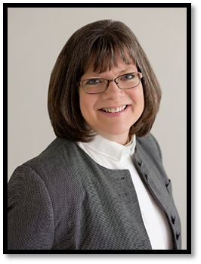
Have you heard the phrase, “Birds of a feather flock together?” This little saying acknowledges what we all know; we gravitate towards the familiar and the comfortable. We like to be with people who think like us, behave like us, believe the same things as us, maybe even look like us. It's natural. I suppose some anthropologist could give a long treatise on herd mentality or the role such affinity plays in survival.
Other observers of societal norms would offer that social media has intensified this phenomenon. Online algorithms supply us with posts that affirm our foregone conclusions. Worse, there are more than a few memes out there that characterize anyone with an opposing view as being fair game for mockery or dismissed as unworthy. Beware of viewpoints being portrayed in the extreme, with no room for nuance or grey area.
It is becoming more and more rare that people gather with birds of another feather, where their world view or assumptions or convictions are challenged. People talk about echo chambers, where we proclaim what we believe to be true only to hear it echo back to us as proof.
The thing is, if we only surround ourselves with people who agree with us, if we never encounter a contrary opinion and explore it for its valid points, if we avoid conversations that invite deeper thinking, broader understanding, or a push back against what we consciously or unconsciously believe to be true then we have stopped learning and our lack of engagement contributes to the polarization of our society and the underlying anger that results from feeling misunderstood.
A remedy for this is intentional engagement and deep listening, not to argue a point or change someone’s mind, but to understand the reasons that support another perspective. To that end, our Synod will be offering a Lenten Kaleidoscope Challenge. Our NGLS Kaleidoscope in Christ task force seeks to provide more opportunities for our synod to see others through the eyes of Jesus so that we can better, as James and elsewhere in scripture urges, “love your neighbor as yourself.”
Because it is more than a little difficult to love what we do not understand or stay present with topics or people that make us uncomfortable.
So during Lent, you are invited to engage the resources on our website under The Kaleidoscope Challenge. Short videos, articles, movies, and books are linked there for you to watch, read, and study. I encourage you to consciously lower your defenses, raise your awareness, and learn something new about racial equity, our indigenous neighbors, and the LGBTQIA+ community. And you are invited to join a small group of people every week via zoom to process and discuss the resources for that week. What do you have questions about? What surprised you? What challenged you? What pricked your compassion? Your curiosity? Your emotions?
On our synod website, www.nglsynod.org, you can register for the cohort of your choosing. A variety of leaders, dates, and times are available.
At a time when people are quick to anger and disagree, I hope that our Church and your church can lead the way toward mutual respect and understanding. As Martin Luther once said, “God doesn’t need your good works, but your neighbor does.” For the sake of community, for the sake of the command of Jesus to love, for the sake of our neighbor, let us do the homework that will lead to authentic witness and put the love we have for Jesus into action.
Yours in Christ,
Bishop Katherine Finegan

