Northern Light Article, Duehring for Feb/March 2023

You Can Learn a Lot from a Dog

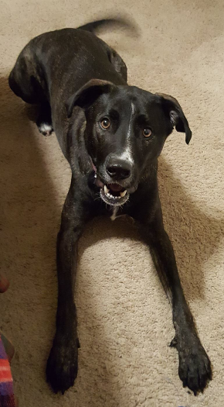
A daily practice of mine is to walk my dog, Juergen. Juergen is always eager to go for a walk. No surprise there! My wife describes Juergen as “4-Legged Joy with a Tail.” I named Juergen after one of my favorite theologians, Juergen Moltmann.

Recently we took a walk in a large pasture area on public land. Fresh snows and ice left the snow deep but very crusty on the top. Juergen was so excited for his walk, but this time he sensed early on that there would be problems. He ran out ahead of me, but he was very much slowed down by the crusty snow breaking way and his legs sinking into the deep snow. It was very difficult for him to “blaze” a new trail on his own.

I felt sorry for Juergen for not having the typical freedom to merely bounce on ahead of me. Eventually, Juergen slowed down. I could tell he was becoming fatigued, and this walking experience was not pleasant at all. I, too, was having difficulty blazing my own trail. I really should have been wearing snowshoes, but with my winter boots I was able to stomp down and create size 13 divots in the deep snow.

What happened next caught my attention. My dog slowed down. He then started following me so that his paws could easily follow in my footprints without him having to break through snow. Even though it slowed him down, Juergen was having a much more enjoyable time following in my clear footprints in the snow.

Sometimes when the snow was not so deep, Juergen would leap out ahead of me and make his own trail. Then, when the snow got deep again, Juergen slowed down and started following my footprints.

You can see the obvious spiritual lesson here! Jesus calls us to follow him. Sometimes we bounce out ahead of Jesus with bold confidence that we can handle whatever life has to throw at us. Then we encounter the inevitable deep snow with an icy crust. We fall in. We have to slow down. For a moment we keep trying to blaze our own trail. Finally, if we are humble enough to slow down, we can wait for the Master to pass. We can more efficiently continue our journey following in the big and confident footsteps of the Master, Jesus.

Jesus has gone before us to show us the way. Jesus said, “I am the Way.” Thanks be to God that Jesus has the patience to wait upon us when we foolishly bolt out ahead and get hip deep in trouble.

That day my dog taught me a lot about my Lord’s loving patience with me and the confident path of Jesus.

